UNIVERSITY OF WAH (UOW)
DEPARTMENT OF COMPUTER SCIENCE



COURSE TITLE: COMPUTER NETWORKS

COURSE CODE: CS – 241

SUBMITTED TO: DR. MUHAMMAD MOHSIN

SUBMITTED BY: SAADI SAFDAR

REG #: UW-24-CS-BS-088

BSCS 3RD B

ASSIGNMENT # 2

Q # 01: Write the following:
a): How TCP implements flow control? Draw figures wherever required.
TCP implements flow control using a receiver-driven sliding window mechanism. The receiver keeps incoming bytes in a TCP receive buffer and, in every ACK, advertises how much free space remains in that buffer as the receive window (rwnd). The sender is not allowed to have more than rwnd bytes unacknowledged “in flight”, so the receiver is never overloaded.
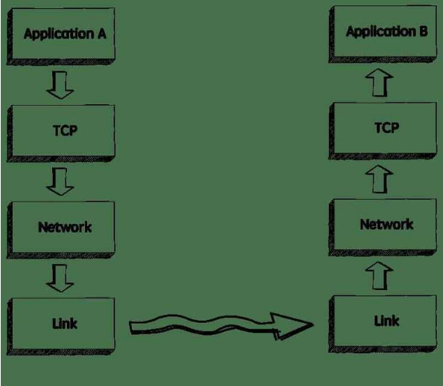
This diagram shows how applications send data to TCP, TCP passes segments to the network, and on the other side TCP buffers the received data before giving it to the application. It motivates why flow control is needed: TCP must protect the receive buffer so that the application can read data at its own (possibly slower) rate.
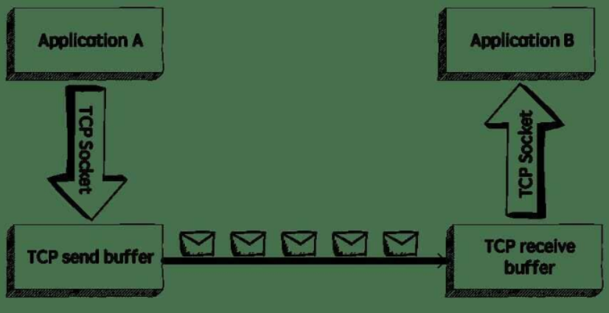
Here TCP stores outgoing data in the send buffer and incoming data in the receive buffer. The free part of the receive buffer is advertised as rwnd in ACKs. As packets arrive, rwnd shrinks; as the application reads data, rwnd grows. The sender always checks this advertised rwnd and only sends new data while “bytes in flight ≤ rwnd”, which automatically slows the sender when the receiver is slow.​
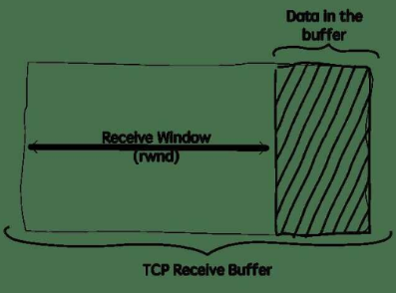
This picture shows the numbered segments inside a window. All segments inside the window can be sent; when ACKs arrive, the window slides forward and new segments enter the window. In this way TCP keeps the amount of unacknowledged data within the receive window, achieving flow control.
b): Describe transport layer protocols in detail?

TCP (Transmission Control Protocol)
TCP provides connection-oriented, reliable transport with in-order delivery, flow control, congestion control, and connection setup via three-way handshake. It uses sequence numbers, acknowledgments (ACKs), checksums for error detection, and retransmissions for lost segments. Applications include web (HTTP), email (SMTP), and file transfer.​

UDP (User Datagram Protocol)
UDP offers connectionless, unreliable transport as a no-frills extension of IP, with minimal header (source/destination ports, length, checksum) and no guarantees for delivery, order, or duplication prevention. It supports multiplexing/demultiplexing via ports and basic error detection but lacks flow/congestion control. Used for streaming (e.g., video calls, DNS, gaming) where speed trumps reliability.​
Feature | TCP | UDP
Connection | Oriented (handshake) | Connectionless
Reliability | Yes (ACKs, retransmissions) | No (best-effort)
Flow Control | Yes (sliding window) | No
Header Size | 20 bytes | 8 bytes
Use Cases | Web, email, file transfer | Streaming, DNS, VoIP

